<!--This file created 2:29 PM 10/29/97 by Claris Home Page version 2.0-->14.1 Project
Midpoint Sums Approximating Double Integrals

Suppose we subdivide the intervals  and 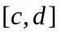 into m subintervals of length  and into n subintervals of length 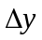 (respectively). If

(1)

denote the midpoints of the ith x-subinterval and the jth y-subinterval (respectively), then 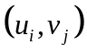 is the midpoint of the ijth subrectangle 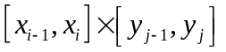. We therefore get the midpoint sum approximation

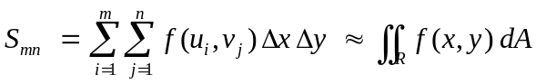 (2)

to the double integral of the function f over the rectangle 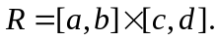

In the paragraphs below we illustrate the use of computer algebra systems to calculate the approximation in (1) with the function 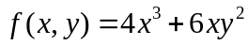 and the rectangle 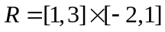 of Example 1 in the text. You can use these techniques to calculate midpoint approximations to integrals such as the ones listed below (or to integrals of your own choice). Compare your numerical approximations using various numbers m and n of subintervals with the exact values of these integrals.

1. 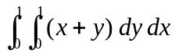 2. 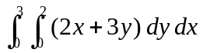

3. 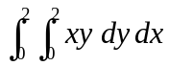 4. 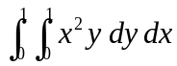

5. 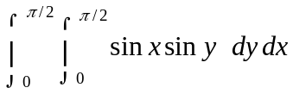 5. 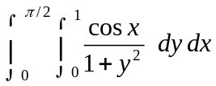

Using Maple

First we define the desired function 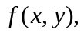 the rectangle 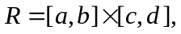 the desired numbers 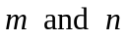 of x-subintervals and y-subintervals (respectively), and the resulting subinterval lengths and 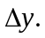

f := (x,y)->4*x^3 + 6*x*y^2:
a:=1: b:=3: c:=-2: d:=1:
m:=8: n:=12:
dx := (b-a)/m: dy:=(d-c)/n:

Then the subinterval midpoints in (1) are defined by

u := i:
v := j->c+(j-1/2)*dy:

We are now ready to calculate and evaluate numerically the midpoint sum in (2).

S := sum( sum(f(u(i),v(j)), j=1..n), i=1..m)*dx*dy:
evalf(S);
310.8750000

For comparison, the exact value of our integral is given by

int( int(f(x,y),x=a..b), y=c..d);
312

Using Mathematica

First we define the desired function the rectangle the desired numbers of x-subintervals and y-subintervals (respectively), and the resulting subinterval lengths and

f[x_, y_] = 4*x^3 + 6*x*y^2;
a = 1; b = 3; c = -2; d = 1;
m = 8; n = 12;
dx = (b - a)/m; dy = (d - c)/n;

Then the subinterval midpoints in (1) are defined by

u[i_] = a + (i-1/2)*dx;
v[j_] = c + (j-1/2)*dy;

We are now ready to calculate and evaluate numerically the midpoint sum in (2).

S = Sum[Sum[f[u[i],v[j]],{j,1,n}],{i,1,m}]*dx*dy // N
310.875

For comparison, the exact value of our integral is given by

Integrate[Integrate[f[x,y], {x,a,b}], {y,c,d}]
312

Using MATLAB

First we define the desired function the rectangle the desired numbers of x-subintervals and y-subintervals (respectively), and the resulting subinterval lengths and

f = inline('4*x.^3 + 6*x.*y.^2')
a = 1; b = 3; c = -2; d = 1;
m = 8; n = 12;
dx = (b - a)/m; dy = (d - c)/n;

Then vectors consisting of the subinterval midpoints in (1) are defined by

i = 1 : m; j = 1 : n;
u = a + (i - 1/2)*dx;
v = c + (j - 1/2)*dy;

Next, and array consisting of the midpoints of the mn subrectangles is given by

[u,v] = meshgrid(u,v);

We are now ready to calculate and evaluate numerically the midpoint sum in (2).

sum( sum(f(u,v) ))*dx*dy
ans =
310.8750

For comparison, a highly accurate value of our integral is given by

dblquad(f, a,b, c,d)
ans =
312

